Shaik Sharifa Jahan

AP22110011103

1. Write a program in assembly language to perform subtraction of 8-bit data.org 100h

mov al,2Ah

sub al,05h

int 21h

ret

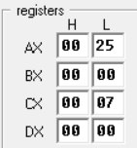

2. Write an assembly language program to perform subtraction of 16-bit data.

org 100h

mov ax,123Eh

sub ax,100Ah

int 21h

ret

